END-TO-END DATA ANALYTICS PROJECT
Banking Data Analysis
A Relational Banking Analytics Pipeline — SQL, PostgreSQL & Power BI

PREPARED BY | Vivek
Project Type | End-to-End Data Analytics Project
Tools Used | PostgreSQL · SQL · Power BI · Excel
GitHub Repository | github.com/Vivek7ok/Banking_data_analysis
Report Date | July 2026

Table of Contents

Executive Summary 2
Project Overview 3
Dataset Overview 4
Data Preparation & Database Design 5
SQL Analysis 6
Dashboard Development 9
Business Insights 13
Business Recommendations 15
Challenges & Data Notes 16
Skills Demonstrated 17
Project Workflow 18
Conclusion 19
Appendix 20

Executive Summary

Business Problem
Retail banks generate high-volume, high-stakes data across customers, accounts, loans, cards, and transactions — data that directly affects credit risk, fraud exposure, and branch profitability. This project builds an analytics pipeline over a realistic, relational banking dataset (branded "PrimeBank" in the dashboard) to answer the questions a bank's management team needs answered: where is deposit and loan growth coming from, which branches and customers carry the most risk, and where is fraud concentrated.

Goal
Design a normalized relational database for a 10-table banking dataset, answer a structured set of business questions in SQL across KPIs, customers, branches, accounts, loans, cards, transactions, support, and risk, and present the results in an interactive, multi-page Power BI dashboard.

Solution
A PostgreSQL schema was defined for all 10 entities with primary/foreign key relationships and performance indexes on high-volume tables (transactions, card_transactions, loan_payments). Ten SQL analysis scripts answer 40+ business questions, and an 8-page Power BI dashboard (Executive, Customer, Branch Performance, Accounts & Transactions, Loan Analysis, Card & Fraud, Support, and Risk Analysis) turns those answers into a navigable, branded reporting tool.

Outcome
The dashboard reports a bank with 60,000 customers, 150 branches, roughly ₹3 billion in total deposits, 22,000 loans issued, 65,000 cards in circulation, and a 0.50% card-fraud rate — and it flags specific, named risk areas (including a high-default branch) that a real risk team could act on directly. These findings are summarized in this report, along with the recommendations already built into the dashboard's Risk Analysis page.

💡 Key Result
A fully relational 10-table banking database (~5.9M rows) modeled in PostgreSQL, analyzed with 40+ SQL business questions, and delivered as an 8-page Power BI risk & performance dashboard.

Project Overview

Background
The project uses a synthetic but realistic banking dataset (the "BankCorp" dataset, presented in the dashboard under the brand "PrimeBank") built specifically to mirror the structure of a real retail bank's core systems: branches and employees, customers and accounts, loans and repayments, cards and card transactions, account-level transactions, and customer support tickets.

Objectives
- Model a normalized, indexed relational database covering all 10 core banking entities
- Answer core business questions using SQL across nine analysis areas: KPIs, customers, branches, accounts, loans, cards, transactions, support, and risk
- Rank branch performance using an advanced multi-metric SQL query (deposits, customers, loans, transactions)
- Visualize findings in an 8-page Power BI dashboard for executive, risk, and operational audiences
- Translate the risk analysis into concrete, actionable business recommendations

Scope
The scope covers descriptive and diagnostic analytics — bank-wide KPIs, customer and branch performance, loan and card risk, and support quality — using the data as provided. It does not include predictive/statistical credit-scoring models.

Technologies Used
- PostgreSQL — relational data storage, indexing, and SQL-based business analysis
- SQL — 10 analysis scripts covering KPI, customer, branch, account, loan, card, transaction, support, and risk queries, including window functions
- Power BI — 8-page interactive dashboard with executive, risk, and operational views
- Excel — supplementary workbook (Bank.xlsx) for pivot-style reporting

Expected Business Value
A bank manager or risk officer using this dashboard can identify top- and bottom-performing branches, quantify loan default and fraud exposure, see which customer segments carry the most risk, and act on dashboard-embedded recommendations — without writing a single query.

Dataset Overview

Source
A 10-table synthetic relational banking dataset (~304 MB, ~5.9 million rows total), documented in Data/README.md and stored in the repository via Git LFS. The full CSV files are tracked as Git LFS objects; this report's business figures are drawn from the project's SQL definitions, the exported Power BI dashboard, and the dataset documentation.

Tables & Size
Table | Rows | Description
branches | 150 | Bank branch locations
employees | 1,800 | Staff, roles, salaries, branch assignment
customers | 60,000 | Demographics, income, credit score
accounts | 95,000 | Savings / current / FD accounts per customer
loans | 22,000 | Home / personal / auto / education / business loans
loan_payments | 600,000 | EMI payment history per loan
cards | 65,000 | Debit / credit cards per customer
card_transactions | 3,000,000 | Card-level spend, includes fraud flag
transactions | 2,000,000 | Account-level deposits / withdrawals / transfers
support_tickets | 25,000 | Customer service complaints & resolutions

Data Relationships
branches connect to employees, accounts, and loans; customers connect to accounts, loans, cards, and support tickets; accounts connect to transactions and cards; loans connect to loan_payments; and cards connect to card_transactions. The complete schema, with primary and foreign keys, is provided in the Data Preparation & Database Design section.

Important Columns
- customers.credit_score / annual_income — used throughout customer segmentation and risk analysis
- loans.status / loan_payments.late_payment_flag — loan health and default risk
- card_transactions.is_fraud / merchant_category — fraud detection and monitoring
- accounts.balance / branch_id — deposit base and branch performance
- support_tickets.satisfaction_score / status — customer service quality

Data Preparation & Database Design
Unlike a raw scraped dataset, this project's source data is a pre-generated, already-clean synthetic dataset (see Data/README.md), so the primary engineering work was schema design, relational integrity, and load performance rather than null-handling or de-duplication.

Database Schema (Sql/Schema.sql)
All 10 tables were defined in PostgreSQL with explicit primary keys and foreign key constraints linking every child table back to its parent entity.
Table | Primary Key | Foreign Keys
branches | branch_id | —
employees | employee_id | branch_id → branches
customers | customer_id | —
accounts | account_id | customer_id → customers, branch_id → branches
loans | loan_id | customer_id → customers, branch_id → branches
loan_payments | payment_id | loan_id → loans
cards | card_id | customer_id → customers, account_id → accounts
card_transactions | card_txn_id | card_id → cards
transactions | transaction_id | account_id → accounts
support_tickets | ticket_id | customer_id → customers

Data Loading
Cleaned CSVs are loaded via PostgreSQL's COPY command (see the load section of Schema.sql), which is significantly faster than row-by-row inserts for multi-million-row tables such as card_transactions (3,000,000 rows) and transactions (2,000,000 rows).

Performance Indexing
Because several tables run into the millions of rows, targeted indexes were added on the foreign keys and date columns used most often in the analysis queries, to keep aggregations fast:
CREATE INDEX idx_txn_account ON transactions(account_id);
CREATE INDEX idx_txn_date ON transactions(txn_date);
CREATE INDEX idx_cardtxn_card ON card_transactions(card_id);
CREATE INDEX idx_cardtxn_date ON card_transactions(txn_date);
CREATE INDEX idx_loanpay_loan ON loan_payments(loan_id);
CREATE INDEX idx_accounts_cust ON accounts(customer_id);
CREATE INDEX idx_loans_cust ON loans(customer_id);
CREATE INDEX idx_cards_cust ON cards(customer_id);

SQL Analysis
40+ business questions were answered using PostgreSQL across ten analysis scripts covering KPIs, customers, branches, accounts, loans, cards, transactions, support, risk, and an advanced branch-ranking query. Representative queries from each area are shown below.

1. Bank-Wide KPIs (01_KPI_Analysis.sql)
SELECT COUNT(*) AS total_customers FROM customers;
SELECT COUNT(branch_id) AS total_branches FROM branches;
SELECT SUM(loan_amount) AS total_loan_amount FROM loans;
SELECT ROUND(AVG(credit_score)::numeric, 1) AS avg_credit_score
FROM customers;
Business meaning: Establishes bank-wide baseline metrics — customer base size, branch footprint, total lending exposure, and average credit quality.

2. Customers Below a Safe Credit Score (02_Customer_Analysis.sql)
SELECT name FROM customers WHERE credit_score < 600;

SELECT occupation, ROUND(AVG(annual_income)::numeric, 1) AS avg_income
FROM customers
GROUP BY occupation;
Business meaning: Flags the sub-prime customer segment for closer underwriting review and profiles income by occupation for segmentation.

3. Top-Performing Branches by Deposits (03_Branch_Performance.sql)
SELECT b.branch_name, SUM(a.balance) AS total_deposits
FROM branches AS b
JOIN accounts AS a ON b.branch_id = a.branch_id
GROUP BY b.branch_name
ORDER BY total_deposits DESC
LIMIT 5;
Business meaning: Ranks branches by deposit base, the core driver of a branch's lending capacity and profitability.

4. Customers With Multiple Accounts (04_Account_Analysis.sql)
SELECT customer_id, COUNT(account_id) AS number_of_accounts
FROM accounts
GROUP BY customer_id
HAVING COUNT(account_id) > 1
ORDER BY number_of_accounts DESC;
Business meaning: Identifies multi-account, higher-value customers — a natural segment for relationship banking and cross-sell.

5. Branches With the Highest Late-Payment Rate (05_Loan_Analysis.sql)
SELECT b.branch_id,
ROUND(COUNT(*) * 100.0 /
(SELECT COUNT(*) FROM loan_payments lp2
JOIN loans l2 ON lp2.loan_id = l2.loan_id
WHERE l2.branch_id = b.branch_id), 2) AS late_payment_percentage
FROM loan_payments lp
JOIN loans l ON lp.loan_id = l.loan_id
JOIN branches b ON l.branch_id = b.branch_id
WHERE lp.late_payment_flag = 1
GROUP BY b.branch_id
ORDER BY late_payment_percentage DESC;
Business meaning: Pinpoints branches with disproportionate loan delinquency — the basis for the branch-audit recommendation in this report.

6. Fraud Rate by Transaction (06_Card_Analysis.sql)
SELECT is_fraud,
ROUND(COUNT(*) * 100.0
/ (SELECT COUNT(*) FROM card_transactions), 2) AS percentage
FROM card_transactions
GROUP BY is_fraud;
Business meaning: Quantifies the share of all card transactions flagged as fraudulent, the single most important card-risk KPI.

7. Monthly Deposit vs. Withdrawal Trend (07_Transaction_Analysis.sql)
SELECT EXTRACT(YEAR FROM txn_date) AS txn_year,
EXTRACT(MONTH FROM txn_date) AS txn_month,
CASE WHEN txn_type IN ('Deposit','Interest Credit','Transfer In')
THEN 'Deposit'
WHEN txn_type IN ('Withdrawal','Fee Debit','Transfer Out')
THEN 'Withdrawal' ELSE 'Other' END AS transaction_category,
SUM(amount) AS total_amount
FROM transactions
GROUP BY txn_year, txn_month, transaction_category
ORDER BY txn_year, txn_month;
Business meaning: Tracks net cash flow month over month, the core liquidity signal for treasury and branch planning.

8. Branches With the Least Satisfied Customers (08_Customer_Support.sql)
SELECT branch_name, ROUND(AVG(satisfaction_score)::numeric, 1) AS avg_sat_score
FROM support_tickets AS st
JOIN accounts AS a ON a.customer_id = st.customer_id
JOIN branches AS b ON b.branch_id = a.branch_id
GROUP BY branch_name
ORDER BY avg_sat_score ASC
LIMIT 3;
Business meaning: Surfaces the branches most in need of service-quality intervention based on real ticket outcomes.

9. High-Risk Customer Identification (09_Risk_Analysis.sql)
SELECT c.name, c.credit_score, l.loan_amount, 'High Risk' AS risk_level
FROM customers c
JOIN loans l ON c.customer_id = l.customer_id
WHERE c.credit_score < 500
AND l.loan_amount > 300000
AND EXISTS (
SELECT 1 FROM loan_payments lp
WHERE lp.loan_id = l.loan_id AND lp.late_payment_flag = 1
);
Business meaning: Combines three risk signals — low credit score, large loan size, and a history of late payment — into a single actionable high-risk flag.

10. Branch Performance Ranking (10_Advanced_SQL.sql)
SELECT acc.branch_id, acc.number_of_customers, acc.total_balance,
COALESCE(ln.total_loan_issued, 0) AS total_loan_issued,
COALESCE(txn.number_of_transactions, 0) AS number_of_transactions,
RANK() OVER (
ORDER BY acc.total_balance DESC, acc.number_of_customers DESC
) AS branch_rank
FROM ( SELECT branch_id, COUNT(DISTINCT customer_id) AS number_of_customers,
SUM(balance) AS total_balance
FROM accounts GROUP BY branch_id ) acc
LEFT JOIN ( SELECT branch_id, COUNT(*) AS total_loan_issued
FROM loans GROUP BY branch_id ) ln
ON acc.branch_id = ln.branch_id
LEFT JOIN ( SELECT a.branch_id, COUNT(t.transaction_id) AS number_of_transactions
FROM accounts a JOIN transactions t ON t.account_id = a.account_id
GROUP BY a.branch_id ) txn
ON acc.branch_id = txn.branch_id
ORDER BY branch_rank;
Business meaning: A window-function ranking that combines deposits, customer count, lending, and transaction volume into a single composite branch-performance leaderboard — used directly to power the Branch Performance dashboard page.

Dashboard Development
The Power BI dashboard (Power bi/Dashbored.pbix), branded "PrimeBank", translates the SQL findings into eight interactive pages with consistent left-hand navigation and year/month filters.

Page 1 — Executive Dashboard
Headline KPIs — total customers (60K), total deposits (approx. ₹3bn), fraud percentage (0.50%), and active loans — alongside deposits by branch, loan amount by status, accounts by status, and a monthly deposits-vs-withdrawals trend line.
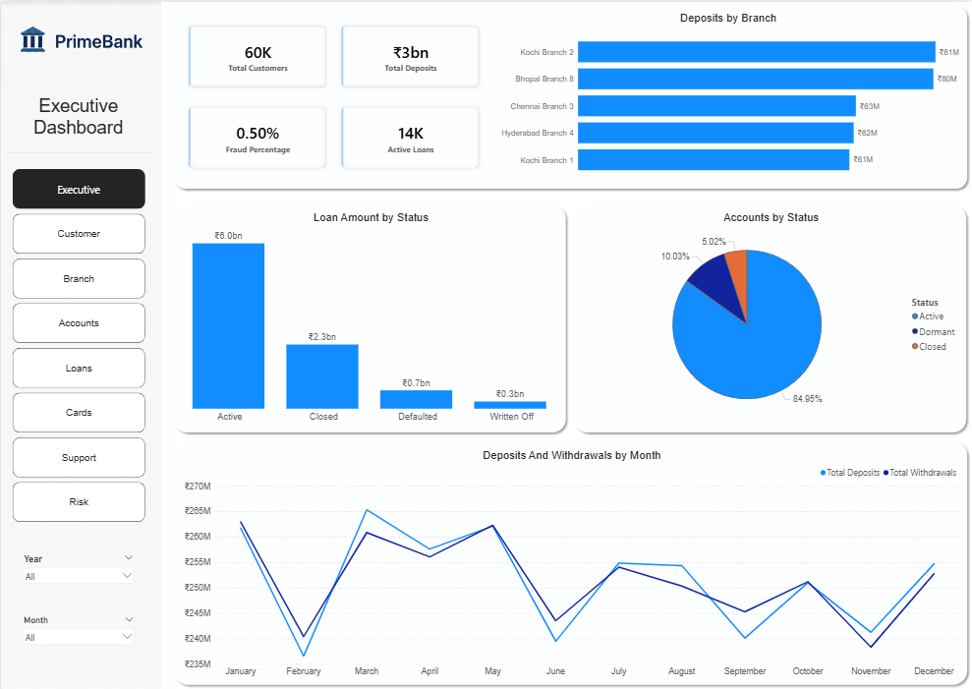
Figure 1: Executive Dashboard — bank-wide KPIs and trend overview

Page 2 — Customer Analysis
Breaks the 60,000-customer base down by gender, state, and join-year, alongside average annual income and average credit score, and a scatter view of income versus credit score.
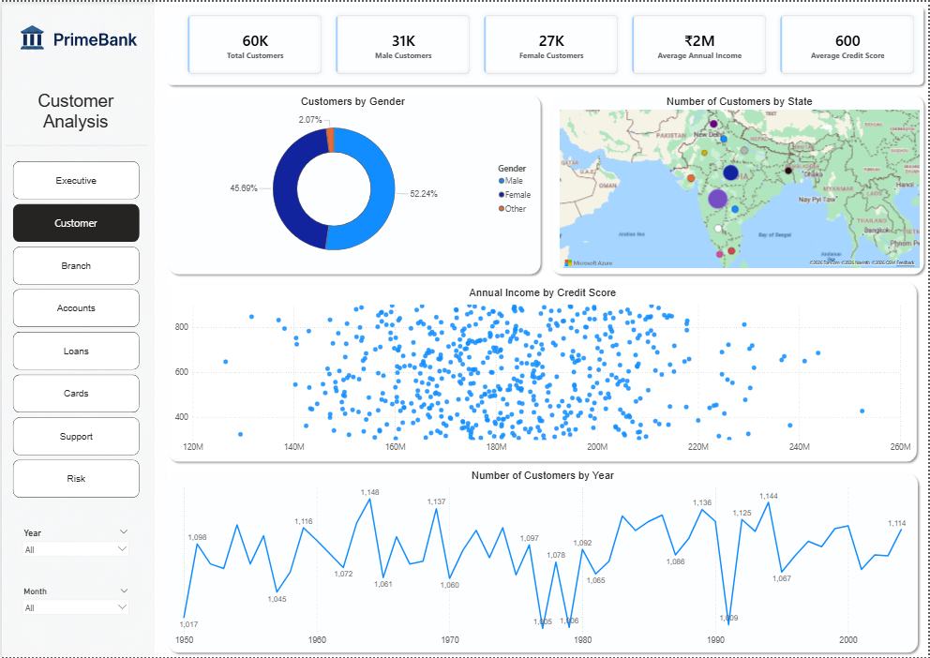
Figure 2: Customer Analysis — demographics and credit profile

Page 3 — Branch Performance
A branch-level scorecard (150 branches, ~1,800 employees) showing deposits by branch and by state, plus a detailed table of customers, deposits, loans issued, and average employee salary per branch.
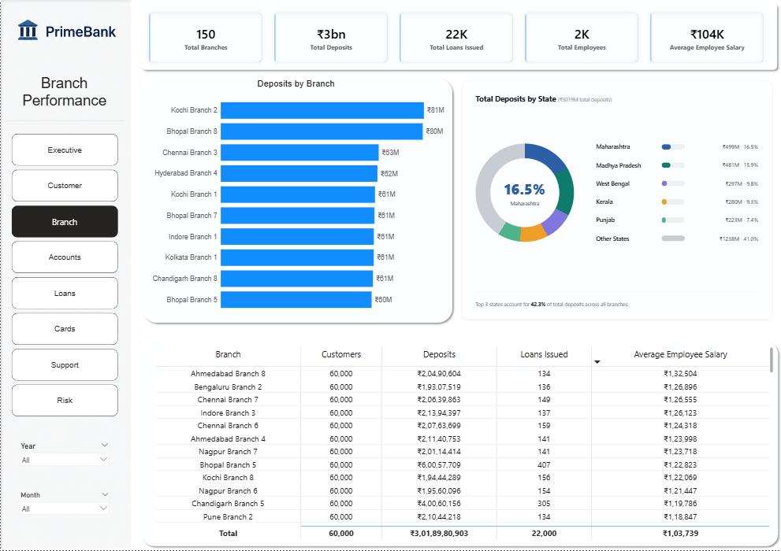
Figure 3: Branch Performance — deposits, loans, and staffing by branch

Page 4 — Accounts & Transactions
Covers the 95,000-account base — active vs. closed accounts, average balance — alongside transaction volume by channel and type, and monthly transaction counts.
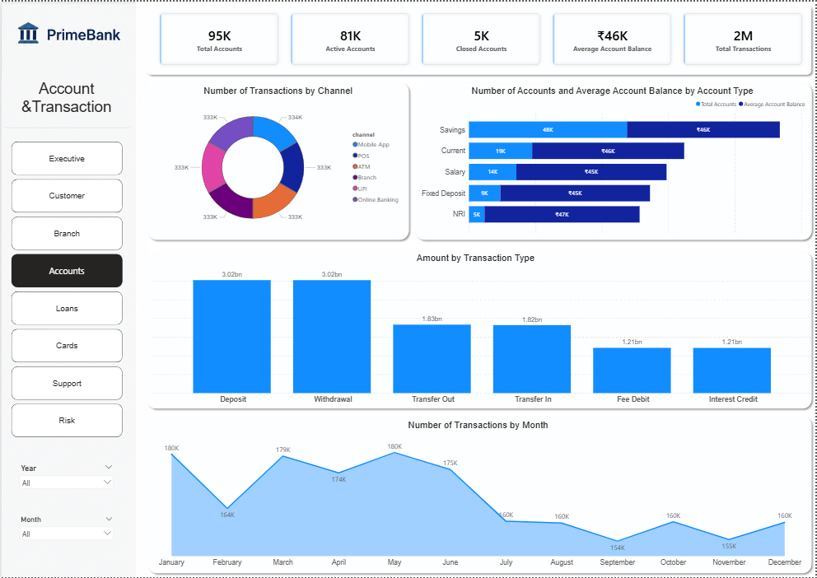
Figure 4: Accounts & Transactions — account health and transaction activity

Page 5 — Loan Analysis
Tracks the 22,000-loan portfolio by status and loan type, average interest rate, late-payment rate, and loan recovery rate, with monthly trend lines for late payments and loan volume.
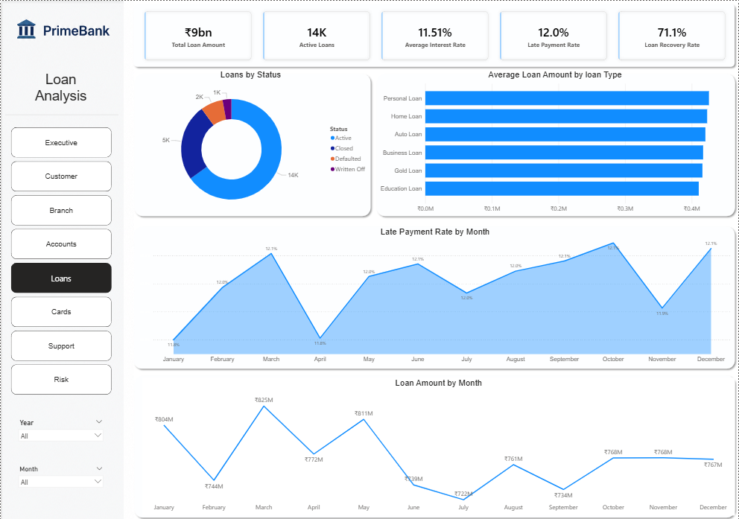
Figure 5: Loan Analysis — portfolio health and repayment performance

Page 6 — Card & Fraud
Covers the 65,000-card portfolio — spending by card type, spending and fraud by merchant category, and card status by type — with the fraud rate (0.50%) as a headline KPI.
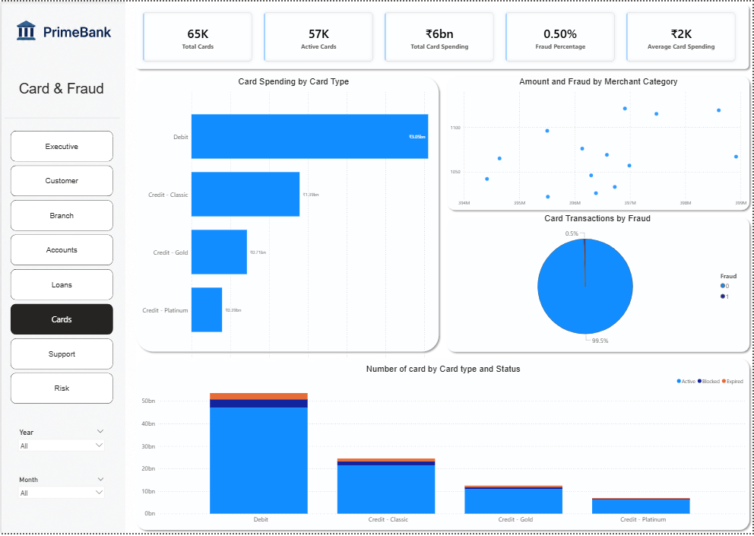
Figure 6: Card & Fraud — card spend and fraud concentration

Page 7 — Customer Support
Summarizes the 25,000-ticket support workload by issue type and status (open / resolved / escalated), with average satisfaction score tracked per issue type.
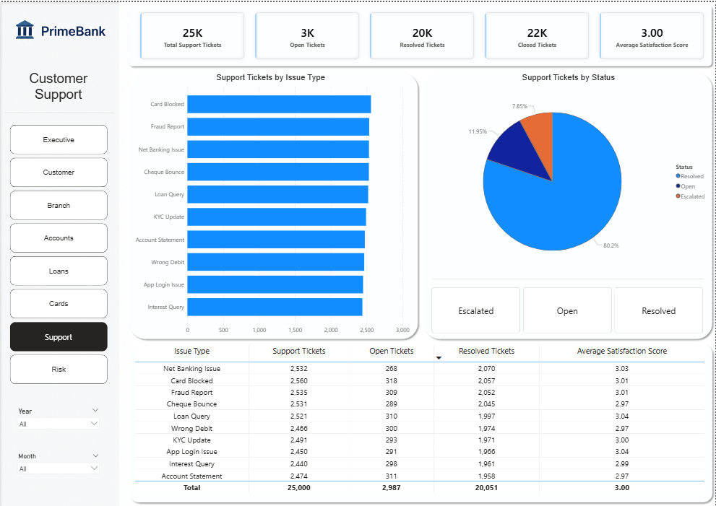
Figure 7: Customer Support — ticket volume, resolution, and satisfaction

Page 8 — Risk Analysis
The most operationally important page: defaulted loans by branch and loan type, high-risk customer and branch counts, and a written business-recommendations panel built directly into the dashboard (reproduced in the Business Recommendations section of this report).
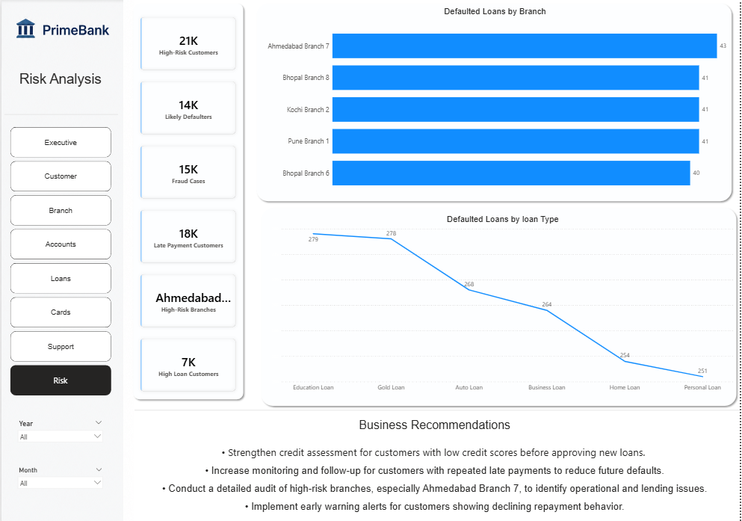
Figure 8: Risk Analysis — default concentration and embedded recommendations

Navigation & Filters
- Left-hand tab navigation across all eight pages (Executive, Customer, Branch, Accounts, Loans, Cards, Support, Risk)
- Year and Month filters applied consistently across pages
- Cross-filtering between KPI cards, charts, and the branch-level data table

Business Insights
The figures below are read directly from the exported Power BI dashboard pages; where a value was not clearly legible in the export, it is described qualitatively rather than estimated.

Bank-Wide Scale
- 60,000 customers served across 150 branches and roughly 1,800 employees
- Approximately ₹3 billion in total deposits and ₹6 billion in total card spending
- 22,000 loans issued, 95,000 accounts opened, and 65,000 cards in circulation

Customer Base
- The customer base is close to gender-balanced, with a slightly higher share of male customers than female customers
- Customer counts are distributed across states, with growth visible year-over-year on the join-date trend

Branch Performance
- Deposit and loan totals vary meaningfully by branch, with a small group of branches (including Kochi, Bhopal, and Chennai locations) leading on deposits
- Average employee salary is broadly consistent across branches, suggesting standardized compensation banding rather than branch-driven pay differences

Loan Portfolio
- The loan book is dominated by Active loans by value, with a smaller share in Closed, Defaulted, and Written Off status
- Late payment rate and loan recovery rate are both tracked monthly on the dashboard, giving an early signal of portfolio deterioration

Card & Fraud
- Card fraud rate stands at 0.50% of all card transactions — small in percentage terms, but material in absolute terms across 3,000,000 recorded card transactions
- Fraud and spending are both concentrated in specific merchant categories, which the dashboard surfaces directly

Customer Support
- Average customer satisfaction score sits at approximately 3.0 out of 5 across support tickets — a middling result that suggests room for service improvement
- Ticket volume is spread across issue types including net banking issues, card blocks, fraud reports, cheque bounces, and loan queries, with broadly similar volumes across categories

Risk Concentration
- The Risk Analysis page identifies specific high-risk branches and customer segments rather than treating risk as evenly spread
- Ahmedabad Branch 7 is explicitly flagged on the dashboard as a high-default branch warranting a dedicated audit

💡 Dashboard Finding
Risk is concentrated, not diffuse — a small number of branches, merchant categories, and customer segments account for a disproportionate share of defaults and fraud, which is exactly where management attention has the highest leverage.

Business Recommendations
The dashboard's own Risk Analysis page includes a management-facing recommendations panel; those points are reproduced below alongside supporting recommendations drawn from the wider SQL and dashboard analysis.

From the Dashboard's Risk Analysis Page
Area | Recommendation
Credit Risk | Strengthen credit assessment for customers with low credit scores before approving new loans.
Loan Monitoring | Increase monitoring and follow-up for customers with repeated late payments to reduce future defaults.
Branch Audit | Conduct a detailed audit of high-risk branches, especially Ahmedabad Branch 7, to identify operational and lending issues.
Early Warning | Implement early warning alerts for customers showing declining repayment behavior.

Additional Recommendations From This Analysis
Area | Recommendation | Expected Impact
Fraud | Add merchant-category-level fraud monitoring rules for the categories the dashboard shows as highest-fraud | Reduces losses from the 0.50% of transactions currently flagged as fraudulent
Branch Strategy | Study the top deposit-generating branches (e.g. Kochi, Bhopal, Chennai locations) to identify replicable practices | Supports deposit growth strategy across underperforming branches
Customer Support | Target improvement plans at the lowest-satisfaction branches and highest-volume issue types | Lifts the average satisfaction score above the current ~3.0/5 baseline
Cross-Sell | Prioritize relationship banking offers for customers who already hold multiple accounts | Grows deposits and product usage among already-engaged customers
Portfolio Management | Track the late-payment-rate and recovery-rate trend lines monthly as an early warning system, not just a point-in-time metric | Enables earlier intervention before loans move to Default/Written Off status

Challenges & Data Notes

Data Access
The full dataset (~304 MB, ~5.9 million rows) is tracked in the repository via Git LFS rather than committed directly as CSV. This report's business figures were therefore drawn from the project's own SQL query definitions, its documentation (Data/README.md), and the exported Power BI dashboard images, rather than being freshly recomputed against the raw tables — a different situation from a repository where the full raw data is directly available.

SQL Challenges
- The original branch-ranking query joined accounts, loans, and transactions directly, which caused row fan-out — a single account row was duplicated once per matching loan and once per matching transaction, inflating SUM(balance) and customer/account counts
- This was fixed by aggregating accounts, loans, and transactions independently in separate subqueries, then combining them with LEFT JOINs on branch_id (using COALESCE so branches with no loans or transactions still appear with 0s), before ranking with RANK()
- Several earlier query drafts contained alias typos (e.g. avg_interset, late_paymetns, amount_raming) and one used SUM() where AVG() was intended — these were identified and corrected during query review

Dashboard Design Decisions
- Chose an 8-page structure split by business function (Executive, Customer, Branch, Accounts, Loans, Cards, Support, Risk) so each audience — executives, branch managers, risk officers, support leads — can go straight to their relevant page
- Embedded the Risk Analysis recommendations directly into the dashboard page itself, so risk findings travel with the visual evidence rather than living in a separate document

Performance Optimizations
- Added indexes on the foreign keys and date columns of the three largest tables (transactions, card_transactions, loan_payments) to keep monthly trend and join-heavy queries fast at multi-million-row scale
- Used PostgreSQL's COPY command for bulk-loading rather than row-by-row inserts, given the dataset's size

Skills Demonstrated
Category | Skills
Database Design | Relational Schema Design, Primary/Foreign Keys, Indexing for Performance
SQL | Joins, Aggregation, Subqueries, Window Functions (RANK), Query Debugging
Domain Analysis | Credit Risk Analysis, Fraud Analysis, Branch Performance, Customer Segmentation
Visualization | Power BI, Multi-Page Dashboard Design, KPI Card Design
Professional | Business Analysis, Problem Solving, Risk Reporting, Stakeholder Communication

Project Workflow
The end-to-end pipeline follows a linear, reproducible flow from raw relational data to risk-ready business decisions:
Stage | Action
1. Source Data | 10-table synthetic banking dataset (~5.9M rows) documented in Data/README.md
2. Schema Design | Relational PostgreSQL schema with primary/foreign keys (Sql/Schema.sql)
3. Data Loading | Bulk load via PostgreSQL COPY, plus performance indexes on high-volume tables
4. SQL Analysis | 40+ business questions answered across 10 SQL scripts (Sql/01–10)
5. Power BI Dashboard | 8-page interactive dashboard (Power bi/Dashbored.pbix)
6. Risk & Business Insights | Branch, loan, fraud, and support-quality findings
7. Recommendations | Dashboard-embedded and report-level recommendations for management

Conclusion
This project models a realistic, 10-table banking system in PostgreSQL, answers 40+ concrete business questions in SQL — spanning KPIs, customers, branches, accounts, loans, cards, transactions, support, and risk — and presents the results in an 8-page Power BI dashboard built specifically for executive and risk-management use.

What the Project Achieved
- A normalized, indexed relational database supporting fast, join-heavy business-question queries at multi-million-row scale
- A structured set of SQL analyses culminating in an advanced, window-function-based branch performance ranking
- An 8-page Power BI dashboard that separates executive, customer, branch, account, loan, card, support, and risk views
- A dashboard-embedded set of risk recommendations, showing the analysis was carried through to actionable output rather than stopping at charts

Key Learnings
- Join fan-out is a real risk in multi-table aggregation — the corrected branch-ranking query shows why aggregating in subqueries before joining is safer than joining first and aggregating after
- Risk is rarely evenly distributed; combining multiple weak signals (low credit score + large loan + late payment history) into a single query is more useful than any one signal alone
- Putting recommendations directly on the dashboard page closest to the supporting evidence increases the odds a business user actually acts on them

Business Impact
The risk-analysis findings point to a small number of high-leverage actions — tighter credit assessment for low-score customers, closer monitoring of repeat late-payers, and a targeted audit of the highest-default branch — that a real bank could act on immediately without needing further modeling.

Appendix

Tool Versions
Specific tool or library version numbers were not recorded in the repository and are not stated here to avoid inaccuracy.

Folder Structure
Folder / File | Contents
Data/ | 10 banking CSV tables (Git LFS) plus dataset README
Sql/ | Schema.sql plus 10 SQL analysis scripts (01_KPI_Analysis.sql – 10_Advanced_SQL.sql)
Power bi/ | Dashbored.pbix and 8 dashboard page exports (1.png – 8.png)
Excel/ | Bank.xlsx supplementary workbook

References
- GitHub Repository: github.com/Vivek7ok/Banking_data_analysis
- Dataset documentation: Data/README.md (BankCorp Synthetic Banking Dataset)

